**INTAKE FORM**

Referring Physician: ________________________ Primary Care Physician: ______________________

**Please list names of other healthcare professionals that have been involved in the management of your pain:**

*Pain Specialist: ___________________________ Spine(orthopedic or neuro) Surgeon: ____________________*

*Chiropractor: _______________________________Physical therapist:____________________________________*

*Neurologist: ________________________________Other: _____________________________________________*

**PAIN HISTORY**

**PLEASE DESCRIBE YOUR PAIN PROBLEM – Mark where your pain located – including any spreading/radiation – please state R for right, L for left or B for both if both sides are involved.**

*Head_____ Forehead______Back of the head____Eye______Face_______Neck______Shoulder________Between Shoulder blades_____ _____Elbow_____ Hand_____Upper back____Chest wall_____Flank______Abdomen_____ Pelvis______Groin______Genitals_______Lower back _____ Buttocks____Thighs_____ Knee_______Calf ___ __ Foot_____Other_______________________________________________________________________________*

Please use the diagram below to demonstrate where your pain is located by shading the painful areas:

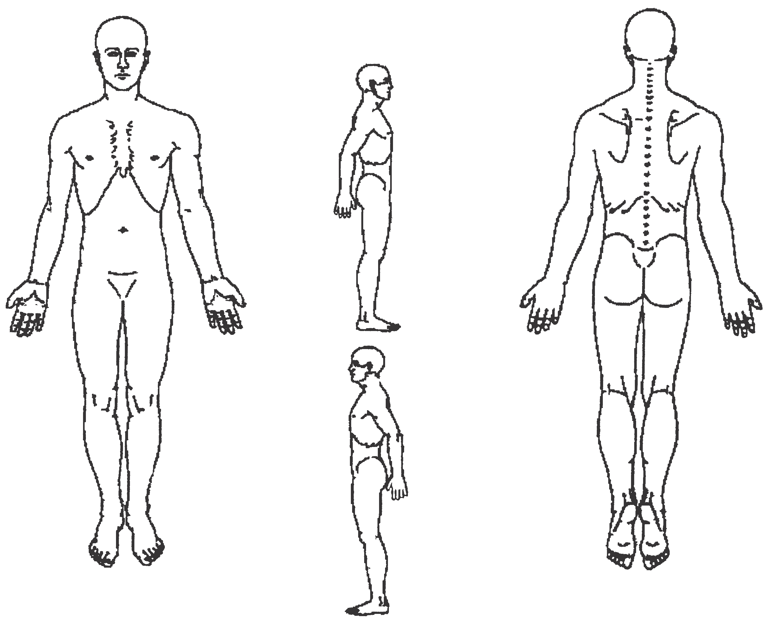

* **WHEN did your pain first begin? (number of months/years or calendar year) __________**
* **HOW did your pain begin? (Please choose one option)**

*No triggering event – pain started spontaneously_________ After an accident______Date of accident______ Work related?_Yes N0_ Pending litigation? Yes N0__ After surgery_______*

*Date of Surgery________Other________________________________________________________________*

* **WHAT DOES YOUR PAIN FEEL LIKE? Please circle any of the words below which describes the character of your pain:**

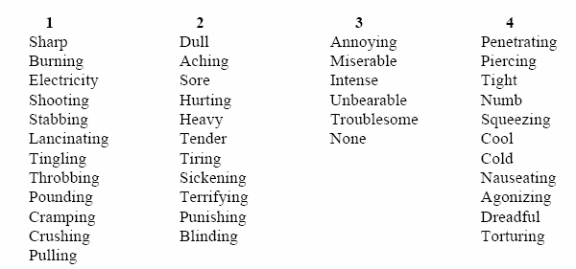

* **HOW DOES YOUR PAIN CHANGE WITH TIME? Please circle any of the words below that describe the pattern of you pain:**



* **What makes your pain WORSE?**

**________________________________________________________________________**

**________________________________________________________________________**

* **Which makes your pain BETTER? ________________________________________________________________________**

**________________________________________________________________________**

* **How does pain affect your lifestyle? (What can you no longer do because of your**

**pain condition?)**

**___________________________________________________________________________**

**PAST MEDICAL HISTORY**

*DIABETES HTN CARDIAC DISEASE PREVIOUS HEART ATTACK CONGESTIVE HEART FAILURE*

*COPD ASTHMA OTHER LUNG DISEASE GERD STOMACH ULCERS HEPATITIS CIRRHOSIS PANCREATIC DISEASE KIDNEY DISEASE STROKE SEIZURES CANCER*

OTHER PROBLEMS___________________________________________________________________________

**SURGICAL HISTORY**

**Please list any operation(s) or surgeries you have had in the past:**

* Type of surgery __________________Year ______ Type of surgery _______________ ____Year ________
* Type of surgery __________________Year ______ Type of surgery _______________ ____Year ________
* Type of surgery __________________Year ______ Type of surgery _______________ ____Year ________
* Type of surgery __________________Year ______ Type of surgery _______________ ____Year ________

**FAMILY HISTORY**

**Please list any medical conditions that run in your family including chronic pain, substance use or back/neck surgeries – specify how they are related to you______________________________________________________**

**____________________________________________________________________________________________**

**ALLERGIES:**

* **Please list your ALLERGIES TO MEDICATIONS or OTHER DRUGS:**

Name of Medication Adverse Reaction Experienced When was the last time this happened?

**______________________________ __________________________________________________________**

**______________________________ _________________________________________________________**

* **Are you allergic to Iodine Contrast Dye (e.g. IVP Dye)?** __Yes __No

If you answered yes, what type of reaction did you have and when?

_______________________________________________________________________

* **Are you allergic to Aspirin or Anti-Inflammatory Medications (e.g. Ibuprofen)?**

__Yes __No If you answered yes, what type of reaction did you have?

_______________________________________________________________________

**CURRENT MEDICATIONS:**

* Bring all current medications including prescription bottles to office visit

**Please list the medications which you currently take FOR PAIN:**

Name of Pain Medication Dosage How Often do you take? Who prescribed it for you?

_______________________________ ______________________________________________________

_______________________________ ______________________________________________________

_______________________________ ______________________________________________________

_______________________________ ______________________________________________________

**Please list the medications (names and doses) which you currently take FOR OTHER MEDICAL CONDITIONS:**

_______________________________ ______________________________________________________

_______________________________ ______________________________________________________

_______________________________ ______________________________________________________

_______________________________ ______________________________________________________

_______________________________ ______________________________________________________

_______________________________ ______________________________________________________

Please review and mark **ALL** items that have applied to you **within the last month** (including today)

***GENERAL HEALTH:*** *None Weight loss Weight gain Fatigue Loss of appetite*

***Females:*** *Pregnant*

***EYES:*** *None Eye pain Double vision Severe Redness Loss of vision*

***EARS:*** *None Ear pain Hearing loss Ringing in ears Dizziness*

***NOSE:*** *None Runny nose Nasal congestion Nosebleeds Sinus pain/pressure*

***MOUTH/THROAT:*** *None Sore throat Problems Swallowing Sores in mouth Tooth pain Hoarseness*

***CHEST/HEART:*** *None Chest pain Racing/pounding heart Leg pain/limp w/walking*

*Problems breathing w/ lying down*

***RESPIRATORY:*** *None Cough Wheezing Shortness of breath Coughing up blood or mucus w/ blood*

***STOMACH:*** *None Heartburn Nausea/vomiting Abdominal pain Vomiting up blood*

***BOWELS:*** *None Diarrhea Constipation Black/bloody stools Unusual change in stool size/shape/color*

***URINARY TRACT:*** *None Blood in urine Increased urination Difficulty urinating Pain w/urination*

***MUSC/SKEL:*** *None Back pain Pain in muscles/joints Limited range of motion in joints*

***SKIN:*** *None Rash Redness Sores Changing moles/warts or other lesions*

***NEUROLOGICAL :*** *None Seizures Problems w/coordination Memory/Sensory issues Weakness/numbness/tingling*

***ENDOCRINE:*** *None Unusual changes w/ skin or hair Increased sensitivity to temperature changes*

***BLOOD:*** *None Bleeding gums Frequent nosebleeds Swollen hands/feet Swollen glands*

*Unusual bruising*

***IMMUNE:*** *None Sneezing Itchy eyes Frequent sinus/ear or respiratory infections*

***MENTAL HEALTH:*** *None Mood swings Emotional changes Anxiety/Depression*

*Thoughts of hurting self or others*

* **Do you take Aspirin?** __ Yes __ No **If you answered yes, when was your last dose?** _______________
* **Do you take Coumadin, Plavix, Pletal, Aggrenox, or Ticlid?** __ Yes __ No

**If you answered yes, when was your last dose? _________________________**

**If you answered yes, will the prescribing physician allow you to discontinue this blood thinner medication for any length of time? ___ Yes** ___ No**

** Please note that you MUST have permission from the physician who prescribes or manages the blood thinner in order to stop this medication.

* **Do you take any herbal medications?**__ Yes __ No **If yes, list: _________________________________**
* **Do you take Vitamin E? ___ Yes ___ No**

**SOCIAL HISTORY**

* **What is your current marital status? (Please check one) How Long?**

*__ Single- Never Married __ Married __________ years __ Divorced __________ years*

*__ Widowed __________ years __ Separated __________ years*

* **With whom do you live? (Check all that apply)**

*__ I Live Alone __ With My Parents __ With Spouse __ With In-Laws*

*__ With Children (ages? _________________) __ With Other Relatives __ With Siblings*

*__ With Others (Significant Other, friends, Roommate, etc.)*

* Do any of them have alcohol or drug problems?____Yes ____No
* **How far did you get in school? (Please check one)**

*__ Less than 8th grade __ Completed College__ Completed 8th grade__ Technical or Business School*

*__ Completed High School __ Advanced Degree (Type ________ ) __ Some College ( ___ years)*

* **Do you currently smoke cigarettes?** __ Yes __ No

**If yes, how many packs do you smoke during an average day?** _____ packs /day **If yes, for how many years have you smoked?** ____ years

**If no and you are a former smoker, when did you quit for good?** _____________

* **Do you drink alcoholic beverages?** ___ Yes ___ No **If yes, how often?**

*__ Daily or More Often__ Less Than Once A Week __ Several Times A Week __ About Once A Week*

*__ I am a heavy drinker*

* **How many drinks do you have each time you consume alcohol?** _______________
* **Have you ever been diagnosed with or treated for drug or alcohol abuse?**

__ Yes __ No

**If yes, when?** _______________ **Please describe ____**_____________________________________

* **Have you ever used illicit drugs.** ___ Yes, ___ No. Do you currently use **illicit drugs.** ___ Yes, ___ No.

W**hat drug__________ last time used**_______________________

* **What do you do for exercise and how often?**

*___Nothing ____Walking ___Jogging ___Spinning ___Biking Other______________*

*___Once a month ___Once a week ___Twice a week ____Thrice a week ___Daily*

**WORK HISTORY**

* **What is your employment status? (please check one)**

*__ Retired _ Able to work but currently unemployed __ Homemaker __ Student*

*__ Not working, on Workers’ Comp. leave from my job since ___________ Working Full Time ( ___ Light Duty )*

*__ Not working, on Disability since (date) ________________ __ Working Part Time*

* **What is (was) your occupation or job title? (please describe)**

**__________________________________________________________________**

* **Which of the following are regular requirements of your job? (Check all that**

**apply to you)**

*__ Heavy Lifting (over 30 pounds) __ Light Lifting (15 - 30 pounds)*

*__ Frequent Stooping, Bending, Twisting__ Standing For Long Periods of Time (over one hour at a time)*

*__ Sitting For Long Periods of Time (over one hour at a time) __ Computer Work*

*__ Other Physical Requirements (describe): ______________________________________________________*

* **How much work have you missed as a result of your pain problem? (check one)**

__ None

*__ I have missed ____ days of work due to my pain problem*

*__ I have missed ____ weeks of work due to my pain problem*

*__ I have missed ____ months of work due to my pain problem*

*__ Not applicable to my situation __ Other: ___________________________________*

* **Please use the following space to describe any other issues related to your pain condition that has not been covered in the above questions. Your comments and concerns are welcome:**

**______________________________________________________________________**

**______________________________________________________________________**

**WHICH DIAGNOSTIC STUDIES HAVE BEEN DONE TO EVALUATE YOUR PAIN PROBLEM?**

* If you have had any of the imaging done please bring copies of the reports or films including EMG/NCS, MRI, CT-scan, or X-rays to office visit **(Please check all that apply)**

Ordered by Whom?

*__ Blood Tests _________________________ X-Rays ______________________________*

*__ MRI Scan ___________________________ CT scan _____________________________*

*__ EMG / Nerve Conduction Studies ________ Bone Scan ___________________________*

*__ other? _____________________ ____________________________________________*

**WHICH TREATMENTS HAVE BEEN DONE FOR YOUR PAIN PROBLEM?**

*Injection Treatments_______________________Chiropractor Treatments_________________________*

*Acupuncture______________________________Surgical Treatments_____________________________*

*Physical Therapy___________________________Psychological Treatments________________________*

*Other_________________________________________________________________________________*

**I certify that I have answered all of the above questions truthfully and to the best of**

**my ability**

Patient Name (Pls. Print)____________________Patient Signature_________________________Date________